Dataset S1:
The distribution of length of short proteins encoded by the chimpanzee and orangutan sequences orthologous to human de novo-originated protein coding genes.

(A) The length of short proteins encoded by the chimpanzee and orangutan sequences.

human genes | chimpanzee | orangutan
ENSG00000176723 | 57 | 98
ENSG00000225917 | 120 | 176
ENSG00000206113 | no start codon | no start codon
ENSG00000232330 | 106 | 102
ENSG00000214780 | 68 | 68
ENSG00000203393 | 108 | 89
ENSG00000225860 | 117 | 117
ENSG00000221972 | 72 | 58
ENSG00000224013 | no start codon | no start codon
ENSG00000227520 | 116 | 42
ENSG00000203863 | 75 | 76
ENSG00000235766 | 91 | 76
ENSG00000229811 | no start codon | no start codon
ENSG00000223857 | 16 | 16
ENSG00000230294 | 42 | 42
ENSG00000205148 | 32 | 32
ENSG00000196273 | 24 | 24
ENSG00000214707 | 116 | 50
ENSG00000224377 | 101 | 13
ENSG00000237858 | 85 | 21
ENSG00000212929 | 66 | 104
ENSG00000236314 | 20 | 20
ENSG00000237270 | 4 | 4
ENSG00000175913 | no start codon | no start codon
ENSG00000225021 | 110 | 121
ENSG00000205066 | 55 | 55
ENSG00000227316 | no start codon | no start codon
ENSG00000187488 | 127 | no start codon
ENSG00000183853 | 20 | 156
ENSG00000203862 | 12 | 12
ENSG00000198447 | 7 | 7
ENSG00000205965 | 129 | 129
ENSG00000184827 | 90 | 90
ENSG00000188745 | no start codon | no start codon
ENSG00000206028 | 107 | 108
ENSG00000204626 | 89 | 90
ENSG00000198411 | 33 | 24
ENSG00000218478 | 87 | 65
ENSG00000204380 | 64 | 64
ENSG00000167117 | 11 | 18
ENSG00000162968 | no start codon | no start codon
ENSG00000204292 | 67 | 74
ENSG00000205557 | 97 | 99
ENSG00000204506 | 69 | 69
ENSG00000204079 | 84 | 70
ENSG00000205201 | 69 | 69
ENSG00000204412 | 13 | 13
ENSG00000176911 | 44 | 12
ENSG00000180838 | 64 | 64
ENSG00000206110 | 18 | 53
ENSG00000214467 | 66 | 66
ENSG00000136242 | 84 | 82
ENSG00000206096 | 61 | 61
ENSG00000204581 | 64 | 64
ENSG00000205424 | 3 | 3
ENSG00000176833 | 59 | 59
ENSG00000204707 | 170 | 170
ENSG00000212693 | no start codon | no start codon
ENSG00000197916 | 3 | 3
ENSG00000205373 | 58 | 58

(B) The distribution of the values of length of short proteins encoded by the chimpanzee sequences divided by human protein length.
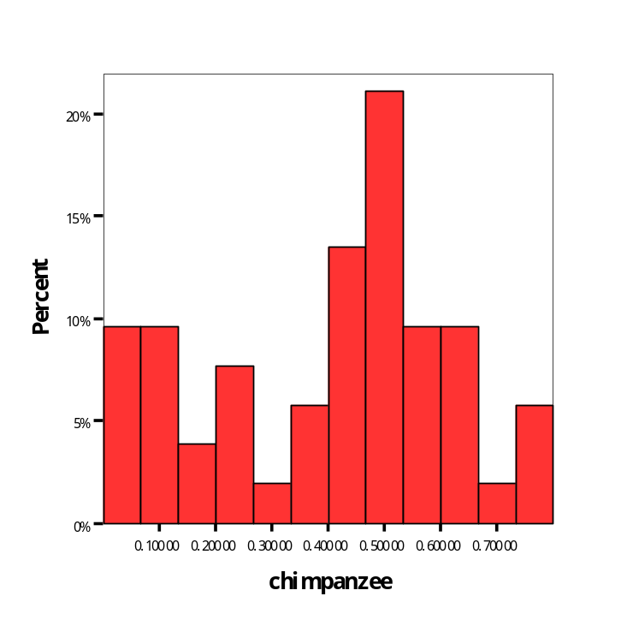

(C) The distribution of the values of length of short proteins encoded by the orangutan sequences divided by human protein length.
